**National Textile University, Faisalabad**



**Department of Computer Science**

|  |  |
| --- | --- |
| **Name:** | Muhammad Hasham Ul Haq |
| **Class:** | BSAI – 6h |
| **Registration No:** | 22-NTU-CS-1361 |
| **Lab Report:** | Lab-3 Class Task |
| **Course Code:** | CSE-4079 |
| **Course Name:** | Internet of Things (IoT) |
| **Submitted To:** | Dr. Nasir Mehmood |
| **Submission Date:** | 20-2-2025 |

***Internet of Things (IoT)***

**Task 1:**

In this task, we placed the text in the center of the LED.

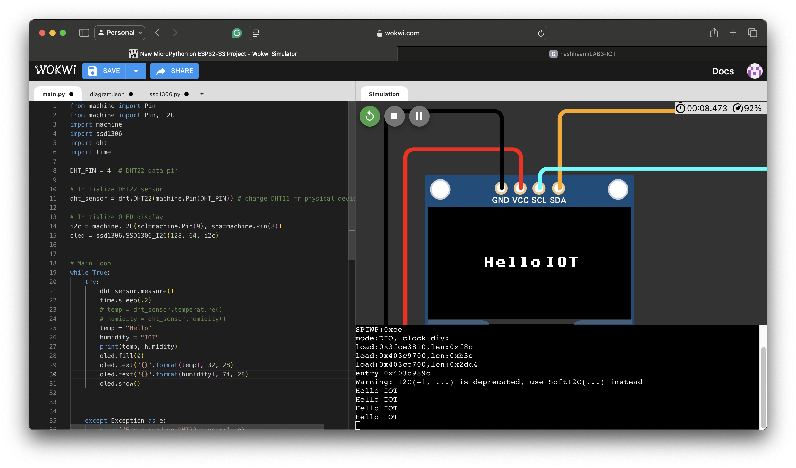

**Task 2:**

